# Design Documentation for Server + DB group

# Homedork - Interactive House

Revision History

|  |  |  |  |
| --- | --- | --- | --- |
| **Date** | **Version** | **Description** | **Author** |
| 16/9/2021 | 0.0 | Initial Design Draft | All |
|  |  |  |  |
|  |  |  |  |
|  |  |  |  |

Design item List

|  |  |
| --- | --- |
| **Requirement Name** | **Priority** |
| D1. System Architecture | Essential |
| D2. Server Architecture | Essential |
| D3. Communication Design | Essential |
| . . . | . . . |

Design Item Descriptions

### D1

Figure 1 - Rough sketch of the entire system architecture

### D2

Figure 2 - Rough initial sketch of server architecture

### D3

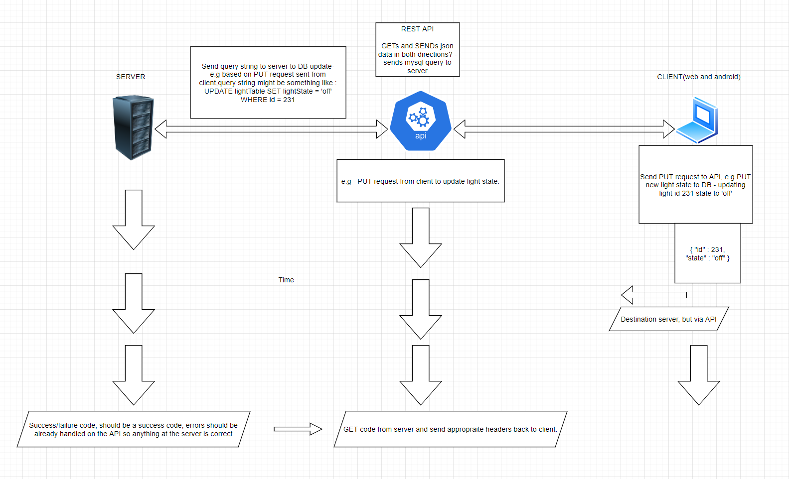

Figure 3 - Communication design between client(unit devices) and Server via a REST API.